Microsoft Azure

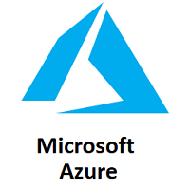

Microsoft Azure is a cloud computing platform that provides a wide variety of services that we can use without purchasing and arranging our hardware. It enables the fast development of solutions and provides the resources to complete tasks that may not be achievable in an on-premises environment. Azure Services like compute, storage, network, and application services allow us to put our effort into building great solutions without worrying about the assembly of physical infrastructure.

This tutorial covers the fundamentals of Azure, which will provide us the idea about all the Azure key services that we are most likely required to know to start developing solutions. After completing this tutorial, we can crack job interviews or able to get different Microsoft Azure certifications.

What is Azure

Microsoft Azure is a growing set of cloud computing services created by Microsoft that hosts your existing applications, streamline the development of a new application, and also enhances our on-premises applications. It helps the organizations in building, testing, deploying, and managing applications and services through Microsoft-managed data centers.

Azure Services

* **Compute services:**It includes the Microsoft Azure Cloud Services, Azure Virtual Machines, Azure Website, and Azure Mobile Services, which processes the data on the cloud with the help of powerful processors.
* **Data services:**This service is used to store data over the cloud that can be scaled according to the requirements. It includes Microsoft Azure Storage (Blob, Queue Table, and Azure File services), Azure SQL Database, and the Redis Cache.
* **Application services:** It includes services, which help us to build and operate our application, like the Azure Active Directory, Service Bus for connecting distributed systems, HDInsight for processing big data, the Azure Scheduler, and the Azure Media Services.
* **Network services:**It helps you to connect with the cloud and on-premises infrastructure, which includes Virtual Networks, Azure Content Delivery Network, and the Azure Traffic Manager.

How Azure works

It is essential to understand the internal workings of Azure so that we can design our applications on Azure effectively with high availability, data residency, resilience, etc.

Backward Skip 10sPlay VideoForward Skip 10s

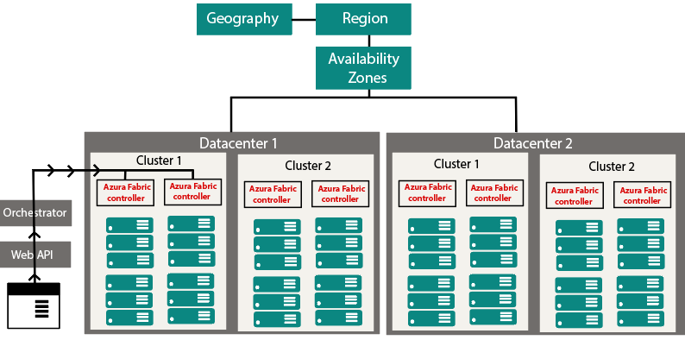

Microsoft Azure is completely based on the concept of virtualization. So, similar to other virtualized data center, it also contains *racks*. Each rack has a separate power unit and network switch, and also each rack is integrated with a software called *Fabric-Controller*. This *Fabric-controller* is a distributed application, which is responsible for managing and monitoring servers within the rack. In case of any server failure, the Fabric-controller recognizes it and recovers it. And Each of these Fabric-Controller is, in turn, connected to a piece of software called *Orchestrator*. This *Orchestrator* includes web-services, Rest API to create, update, and delete resources.

When a request is made by the user either using PowerShell or Azure portal. First, it will go to the Orchestrator, where it will fundamentally do three things:

1. Authenticate the User
2. It will Authorize the user, i.e., it will check whether the user is allowed to do the requested task.
3. It will look into the database for the availability of space based on the resources and pass the request to an appropriate Azure Fabric controller to execute the request.

Combinations of racks form a cluster. We have multiple clusters within a data center, and we can have multiple Data Centers within an Availability zone, multiple Availability zones within a Region, and multiple Regions within a Geography.

* **Geographies:**It is a discrete market, typically contains two or more regions, that preserves data residency and compliance boundaries.
* **Azure regions:**A region is a collection of data centers deployed within a defined perimeter and interconnected through a dedicated regional low-latency network.

Azure covers more global regions than any other cloud provider, which offers the scalability needed to bring applications and users closer around the world. It is globally available in 50 regions around the world. Due to its availability over many regions, it helps in preserving data residency and offers comprehensive compliance and flexible options to the customers.

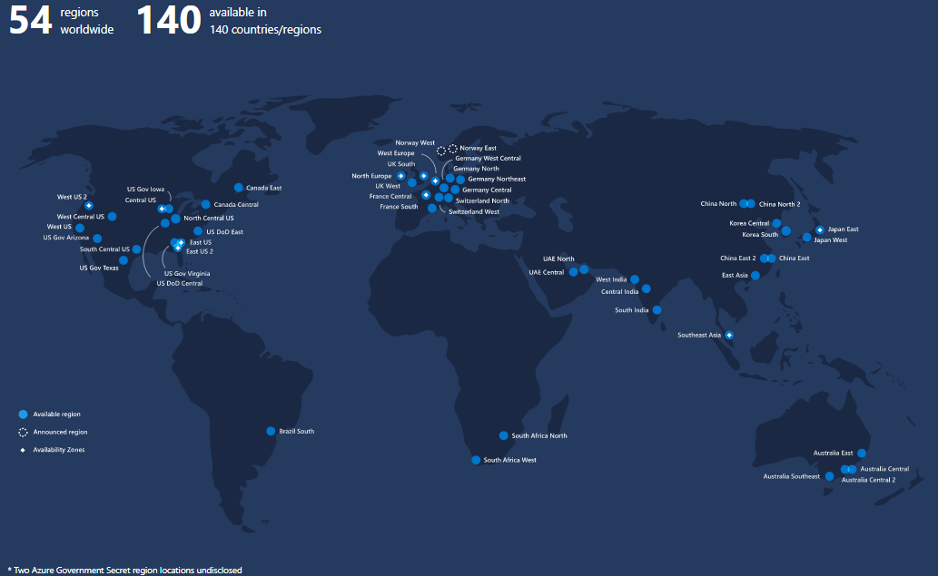

* **Availability Zones:**These are the physically separated location within an Azure region. Each one of them is made up of one or more data centers, independent configuration.

Azure Pricing

It is one of the main reasons to learn Microsoft Azure. Because Microsoft is providing free Credits in the Azure account to access Azure services for free for a short duration. This credit is sufficient for people who are new at Microsoft Azure and want to use the services.

Microsoft offers the **pay-as-you-go** approach that helps organizations to serve their needs. Typically the cloud services will be charged based on the usage. The flexible pricing option helps in up-scaling and down-scaling the architecture as per our requirements**.**

Azure Certification

Microsoft Azure helps to fill the gap between the industry requirement and the resource available. Microsoft provides Azure Certification into three major categories, which are:

* **Azure Administrator:** Those who implement, monitor, and maintain Microsoft Azure solutions, including major services.

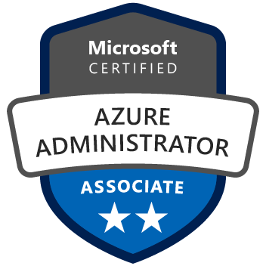

* **Azure Developer:** Those who design, build, test, and maintain cloud solutions, such as applications and services, partnering with cloud solution architects, cloud DBAs, cloud administrators, and clients to implement these solutions.



* **Azure Solution Architect:** Those who have expertise in compute, network, storage, and security so that they can design the solutions that run on Azure.

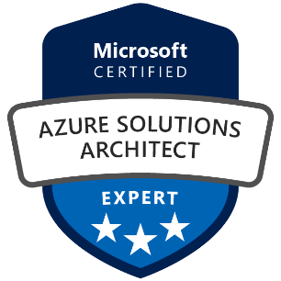

All these certifications are divided into different levels. If anyone is planning to get certified, then he/she first has to get an associate-level certification and then go for the advanced level.

Azure Portal Overview

Azure portal is a platform where we can access and manage all our applications at one place. We can build, manage, and monitor everything from simple web-apps to complex cloud applications using a single console.

So, first of all, to log into the Azure portal, we need to register. And, if we are registering for the first time, we will get 12 months of popular free services. And also, depending on the country, we will get some amount of free credit that needs to be consumed within 30 days. And in addition to all these things, we will get some services that are free forever.

So, make sure you are completely ready to try all the services before you register for Azure because that credit is only available for 30 days.

**Creating an Azure Account**

Backward Skip 10sPlay VideoForward Skip 10s

**Step 1:**Open <https://azure.microsoft.com/en-us/free/> then click on *Start free;*it will redirect you to the next step.

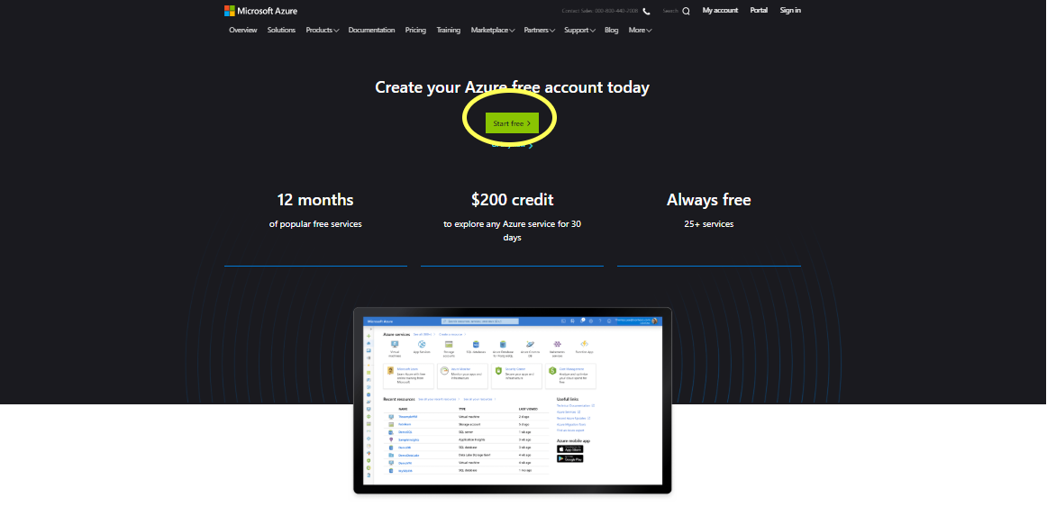

**Step 2:** It will ask you to login with your Microsoft account. If you already have a Microsoft account, you can fill the details and login. And if you don?t have one, you must signup first to proceed further.

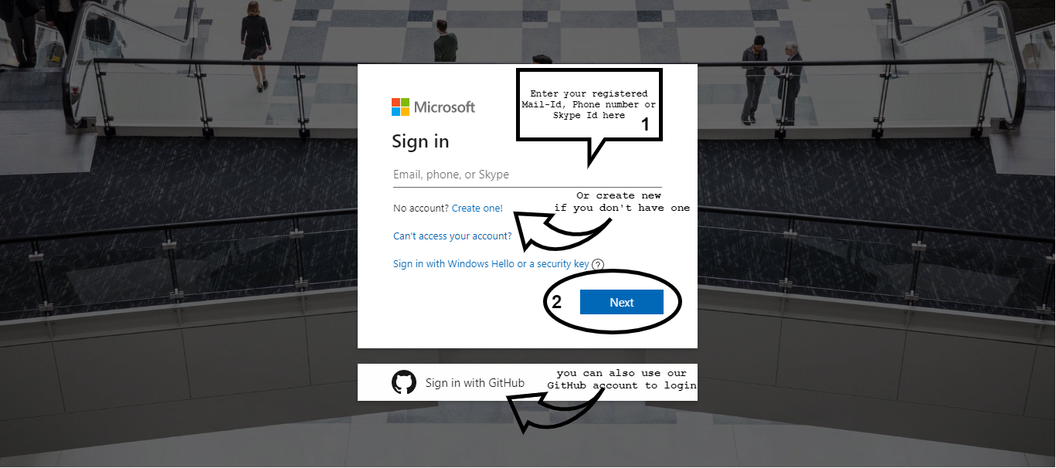

**Step 3:**After logging in to your Microsoft Account. You will be redirected to the next page, as shown below. Here you need to fill the required fields, and they will ask for your credit card number to verify your identity and to keep out spam and bots. **You won’t be charged unless you upgrade to paid services.**

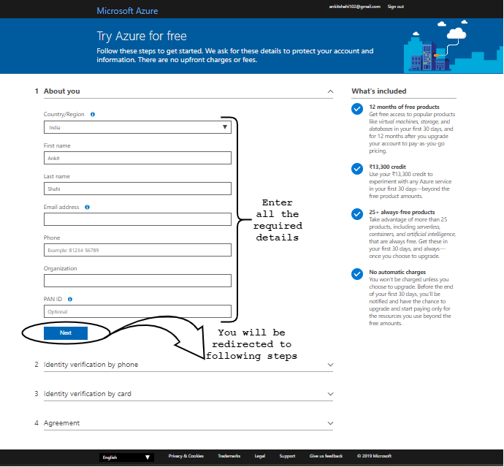

**Step 4:**After filling all the details, it will ask you to check the privacy and agreement. Click the checkbox and then click on Sign up.

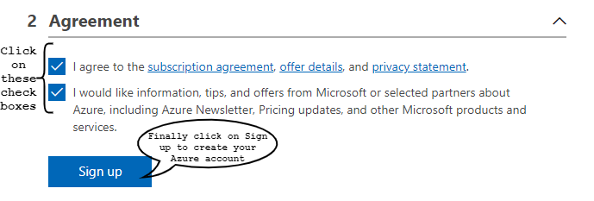

**Step 5:**Your free Account is created, and you will be redirected to the Azure homepage, as shown in the figure below. You can take a tour of Azure services.

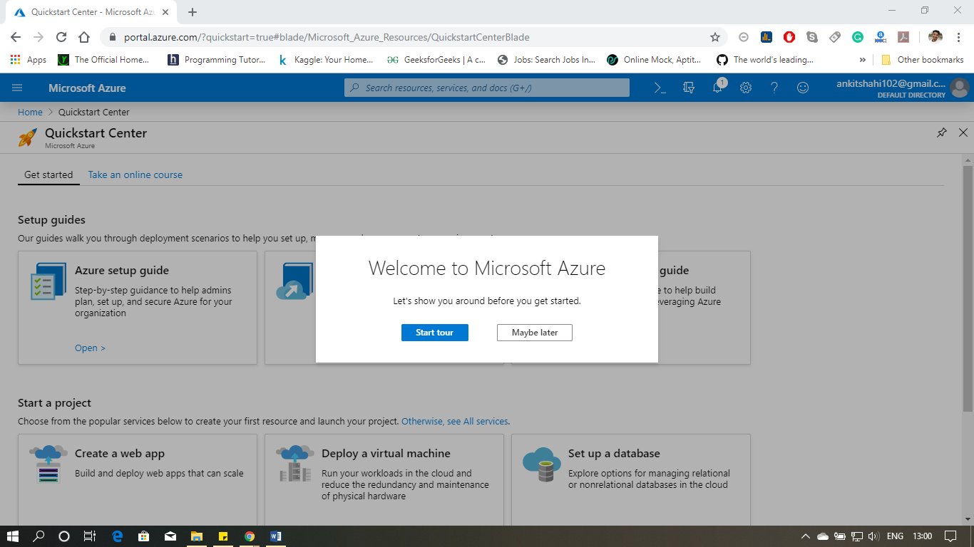

When you log-in to Azure for the first time. The Azure portal looks similar to the picture given below. We will see popular tools and services on the homepage.

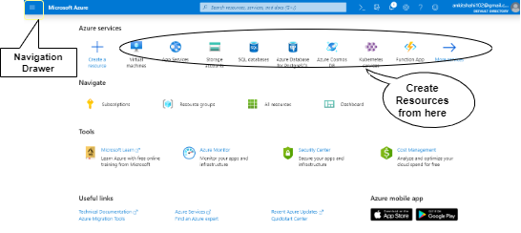

**Creating a Resource**

To create a resource, you can select any resource form the homepage.

Or, if you want to create another resource that is not on the homepage, you can browse the *Navigation Drawer* on the top left corner of the screen.

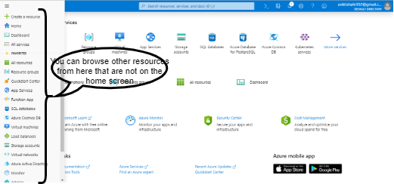

In case if you can't find the right resource in the navigation drawer, you may click on "All Service" in the navigation drawer, and the following window will appear with all the services available in Azure.

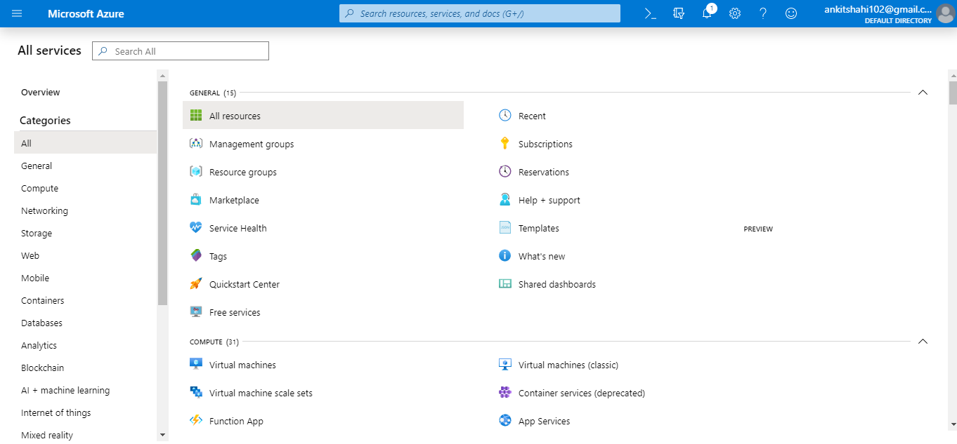

There is one more way to create a resource. Click on "Create a resource" and then type the desired resource name in the search box.

This portal not only includes the services provided by Azure but also includes service provided by the third-party providers on the platform of Azure. They were using CPU or virtual machines of Azure and deployed their platform on it and offering that platform as a Service to you on a pay as you go basis.

**Resource Group:** A container that holds the related resources for an Azure solution. It can include all the resources for the solution or include only those resources which you want to manage as a group. Resource groups are containers of resources that have a common lifecycle or share an attribute such as "all SQL servers" or "Application Attendance".

**Creating a Resource Group**

**Step 1:** Hover your cursor over the "Resource groups" button inside the navigation drawer, then click on "Create" in the appeared pop up.

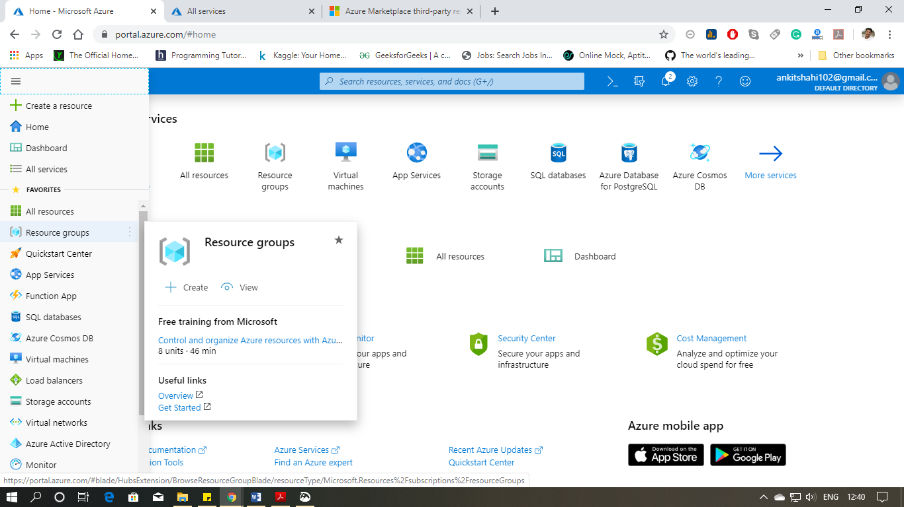

**Step 2:**In the next window, you have to fill the "*Subscription"* type, Resource group name, and Region. Then click review + create or next (to add tags).

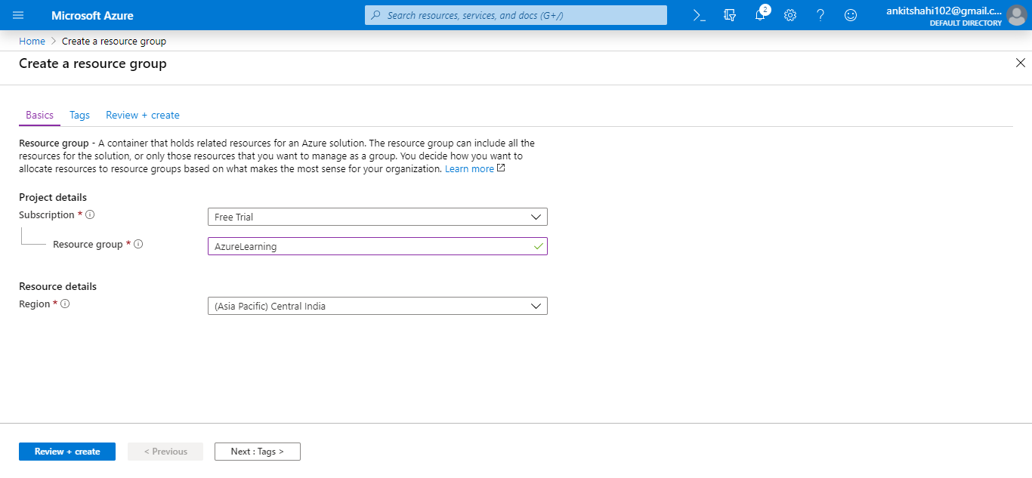

**Step 3:**You are now on the *Tags*window, where you can create a tag to organize Azure resources by categories logically. We have to give it a *name*and *value.*Click Next

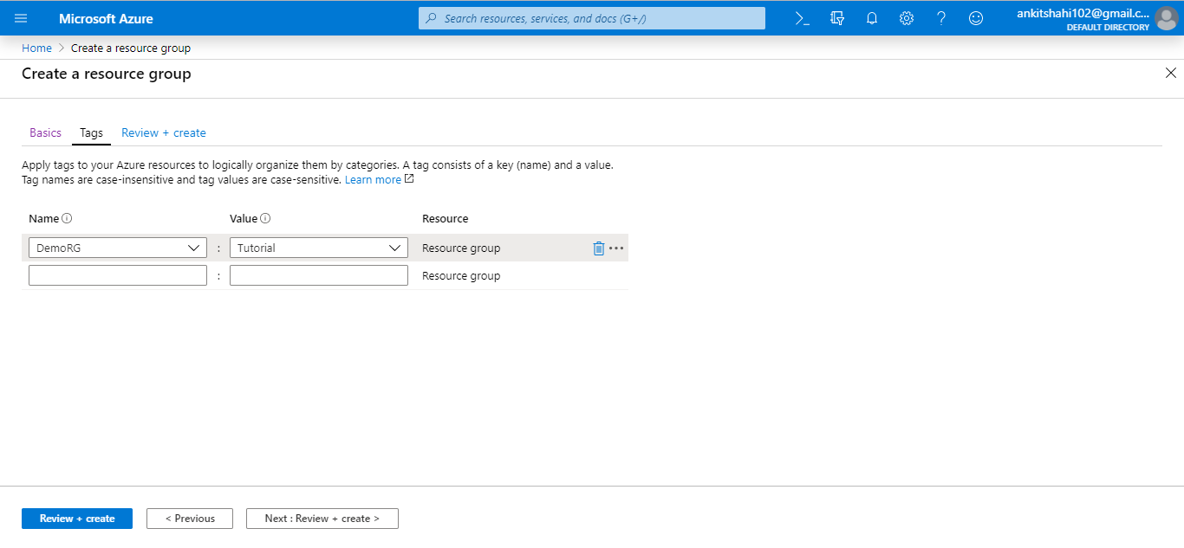

**Step 4:**You are now on the Review + Create window, Check the details shown below, if they are correct, then click on create.

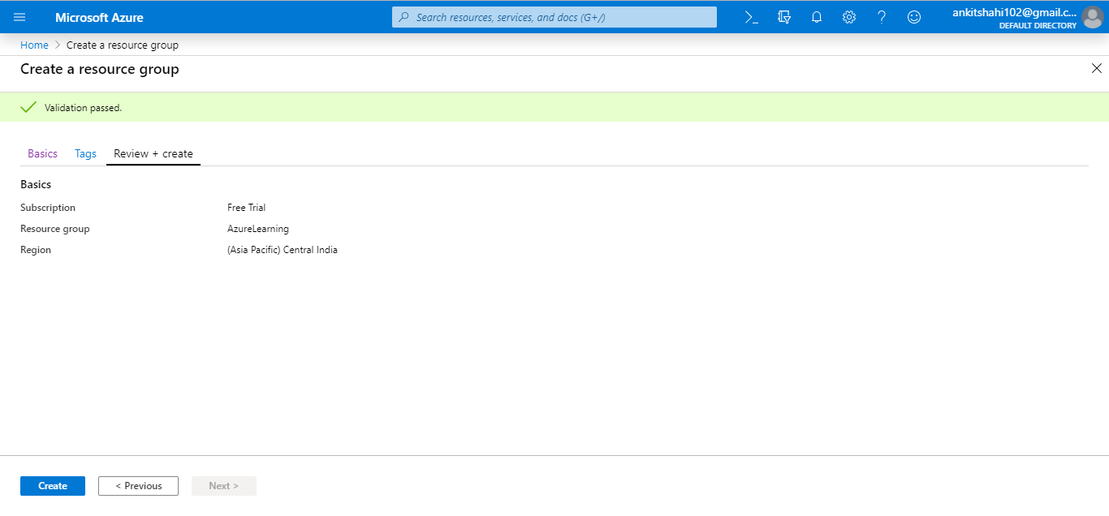

**Step 5:**You will be redirected to the homepage, and a notification will appear showing the Resource group is created.

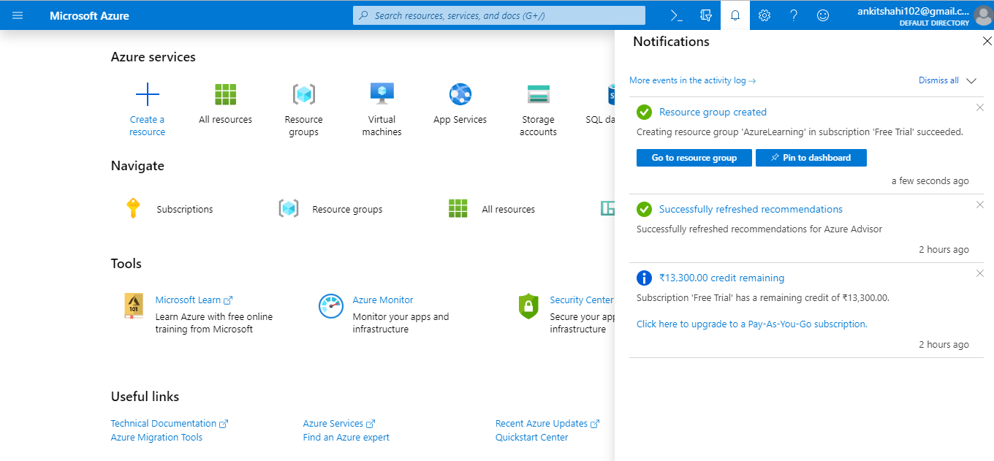

**Step 6:**Click on *Go to Resource group*to view the resource group window.

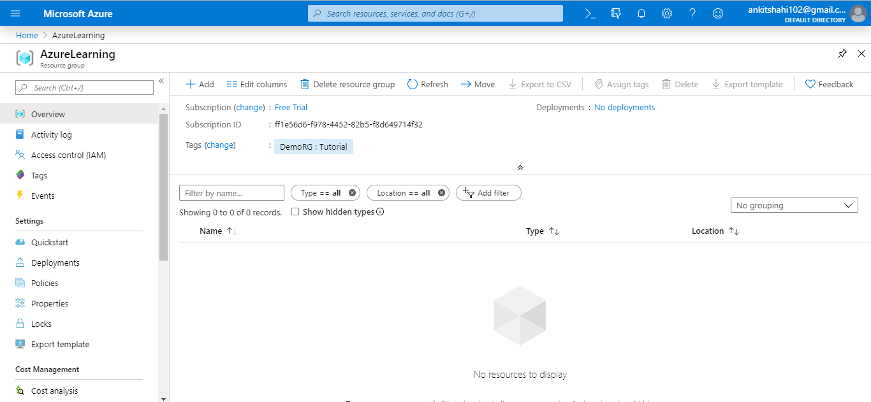

Let's have a quick look at the menu item of this page, but remember it may be different for different resources. For example, the configuration setting will be different for VMs as compared to databases.

1) **Overview:** On the overview pan, we can see all the resources that belong to that resource group and also some Metadata of the resource groups such as to which subscription it belongs to, any tags associated with it, what deployments had been carried out, etc.

2) **Activity log:**It provides administrative activity data that has been carried out on that particular resource. So, in this case, we create a resource group. Hence we have one update resource succeeded. So when we click on it, we can see the Metadata associated with it, and when we click on JSON, we can see what operations have been carried-out (See figure below).

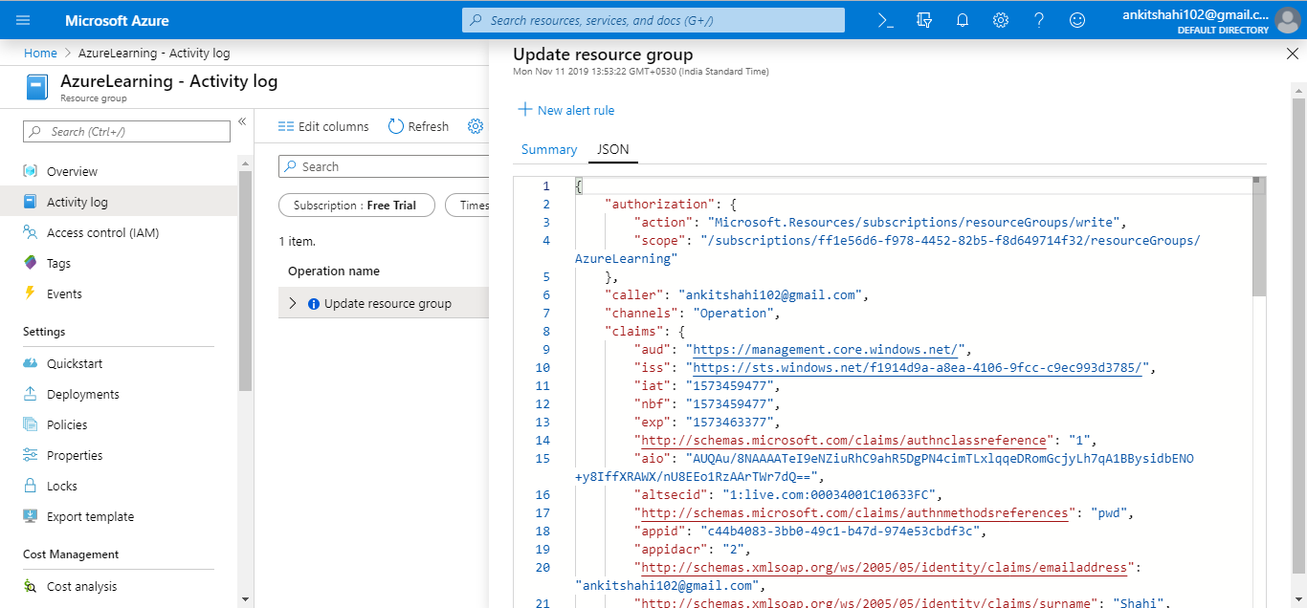

3) **Access control (IAM):** If we want to delegate access to any resource to somebody else, then we can assign a contributor role or owner role to any resource group to somebody. And the details of this role-based access control we can find on the Security Services page of this tutorial.

4) **Tags:** We can assign Tags to any resource in Azure to classify them into categories.

5) **Events:** Any events that are happening in any particular resource group, we can subscribe to those events and do something with it. For example, a virtual machine has been started or stopped. In that case, we can capture the event and send an email to somebody.

6) **Deployment:** We can see any implementations that happened here.

7) **Policies:** We can create and view policies here.

8) **Cost Management:** We can view the resource cost here.

9) **Monitoring:** We can set alerts, see the metrics associated with this resource group, diagnostic settings, and so on.

**Subscription**

To view subscription. Go on the search box and type subscription and click on "*Subscription,"* as shown in the figure below. You can see the subscribed services here.

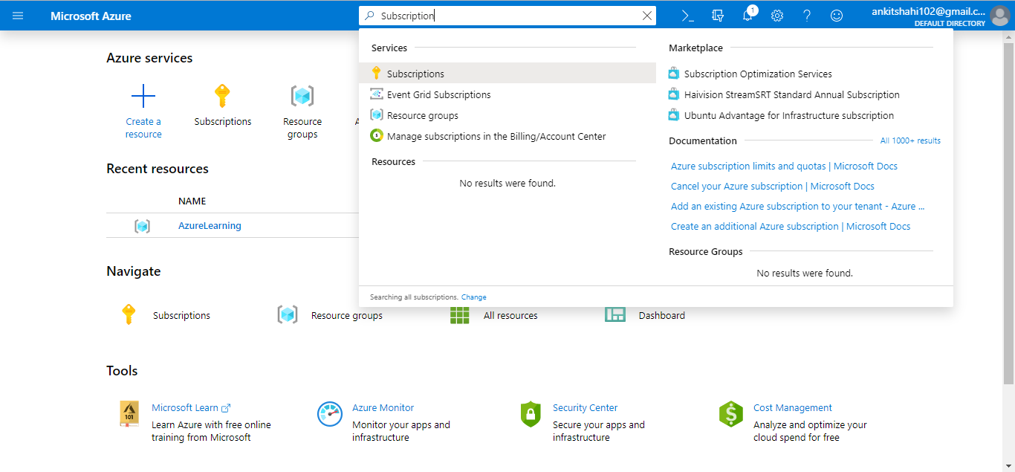

We are subscribed to the Free Trial here. See the figure below.

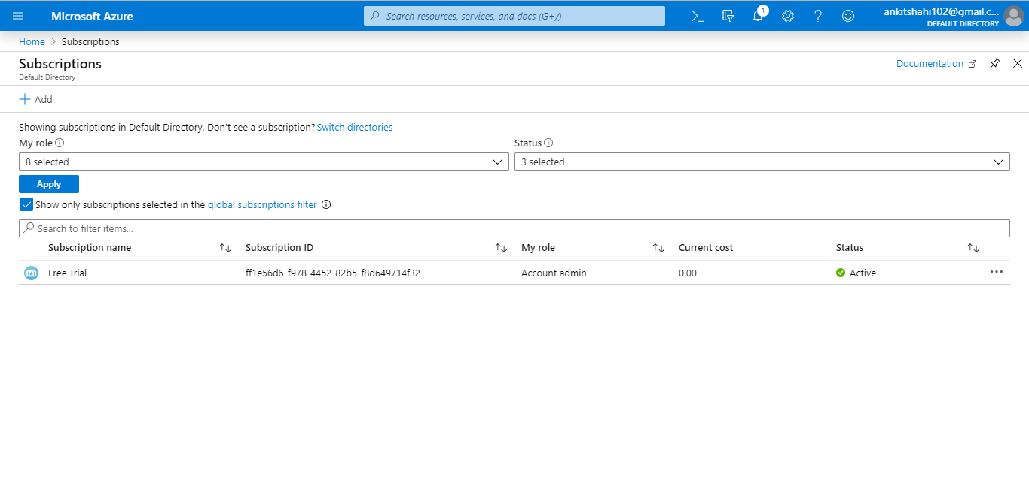

When you click on the subscription, you can view all the details, which includes the subscription name, Cost, ID, to which directory it belongs to, and billing period.

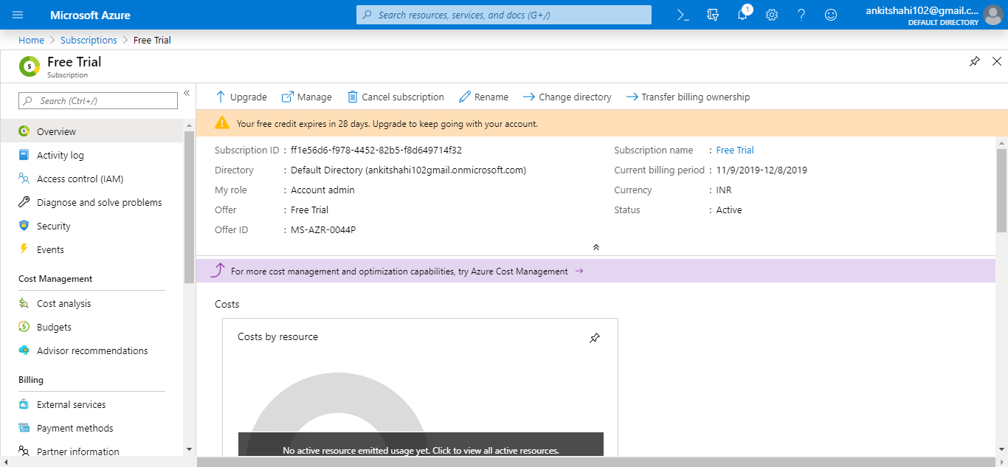

There is an integrated management portal, which we need to see.

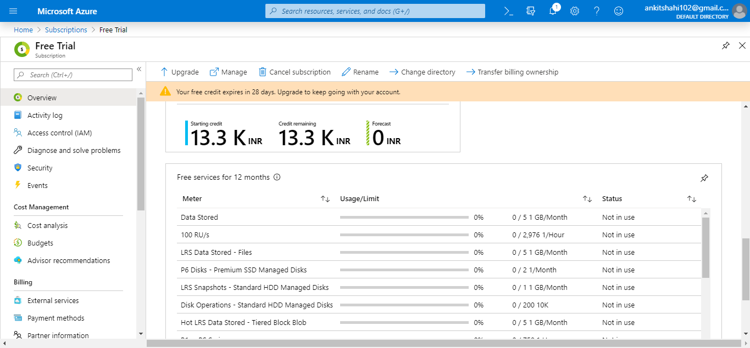

It is a portal where we can see all the subscriptions we have.

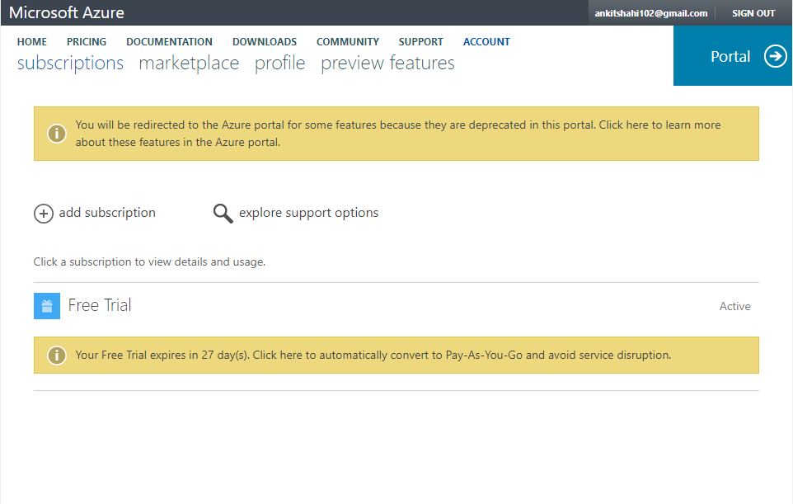

So we can see here, we have one free subscription. If we click on Free Trial, we can see all the costs we have incurred, and we can see the billing history, and also we can set alerts. For example, if the cost is crossing a certain limit, then we will get alerted.